OCR GCE A

COMPUTER SCIENCE PROJECT

H446-03

Name - <INSERT CANDIDATE NAME>

Candidate Number - <INSERT CANDIDATE NUMBER>

<INSERT SCHOOL NAME > - <INSERT CENTRE NUMBER>

Title of Project - Davacis

**\*Details removed due to GitHub backup being public due to git client license.**

H446-03 – Project CONTENTS

Table of Contents

A. Analysis 3

B. Design 3

Systems diagram 3

C. Developing the coded solution (“The development story”) 3

D. Evaluation 3

Project Appendixes 4

# A. Analysis

**Problem Identification:**

I believe that there is a gap for a first-person RPG with a detailed magic system that revolves around attempting to push higher and higher into a central procedural tower.

I’ll need to employ abstraction in several ways to enable more efficient design and remove irrelevant information or information that is too complex.

I can employ abstraction by generalisation to several classes, items, entities, quests and structures for example can all have a base class that sub-classes inherit from. For examples weapons, consumables and armour can inherit from an “item” parent and extend the functionality of the class.

Representational abstraction can be used to remove unnecessary information, the player’s stats for example would simply be “strength” or “intelligence” rather than having realistic physiological details. The tower would also not need to be a realistic blueprint as it would not add anything to the user’s enjoyment of the game and only take up development time and processing power.

I’ll need to employ decomposition to anticipate how to implement features so that they function cohesively together. This future planning and thinking will reduce the amount of refactoring needed to make systems work together. I could break down my game into its different aspects, for example making the inventory, combat and movement into their own problems, and breaking them down further in order to tackle them in an easier, and more modular fashion.

I’ll also need to think concurrently about the interactions between my game systems, ensuring for example that enemies operate independently of each other, and the player and consider the passing of data between systems and their order of execution.

Stakeholders:

**Stakeholders:**

The stakeholders of this project are the players of the game. My target market is RPG gamers, fantasy / technology theme enthusiasts and generally gamers above the age of 12.

There exists a large market of RPG games but I have seen few employ a central goal of progressing through a structure and having other gameplay loops feed back into this. Hence, I believe I am offering a unique experience to RPG gamers and with an uncommon theme, being technology blended with magic.

By looking at successful games in the genre and by surveying my target audience I can ensure that I give the stakeholders the best experience possible.

The survey conducted is discussed ahead in the research section along with specific stakeholder needs.

My stakeholders will be able to use the solution by downloading it from digital stores, such as Itch.io, Steam and Game Jolt. This would allow for stakeholders to play on PC, which would enable me to reach a wide audience due to the size of the PC userbase. The game would be first developed for windows, as most of the audience surveyed used the Windows OS, a console port would be out of scope of this project within the time frame and resources available to me, and I believe that the genre of game does not lend itself well to mobile gaming.

The solution will be suitable for the stakeholders by meeting their needs outlined in the criteria I have produced and by employing iterative development with user feedback at key points to iterate on gameplay systems in order to make it as enjoyable and suitable for the stakeholders.

A survey was conducted with the target audience, and the results somewhat changed the focus of the game but many of the core elements were supported by this.

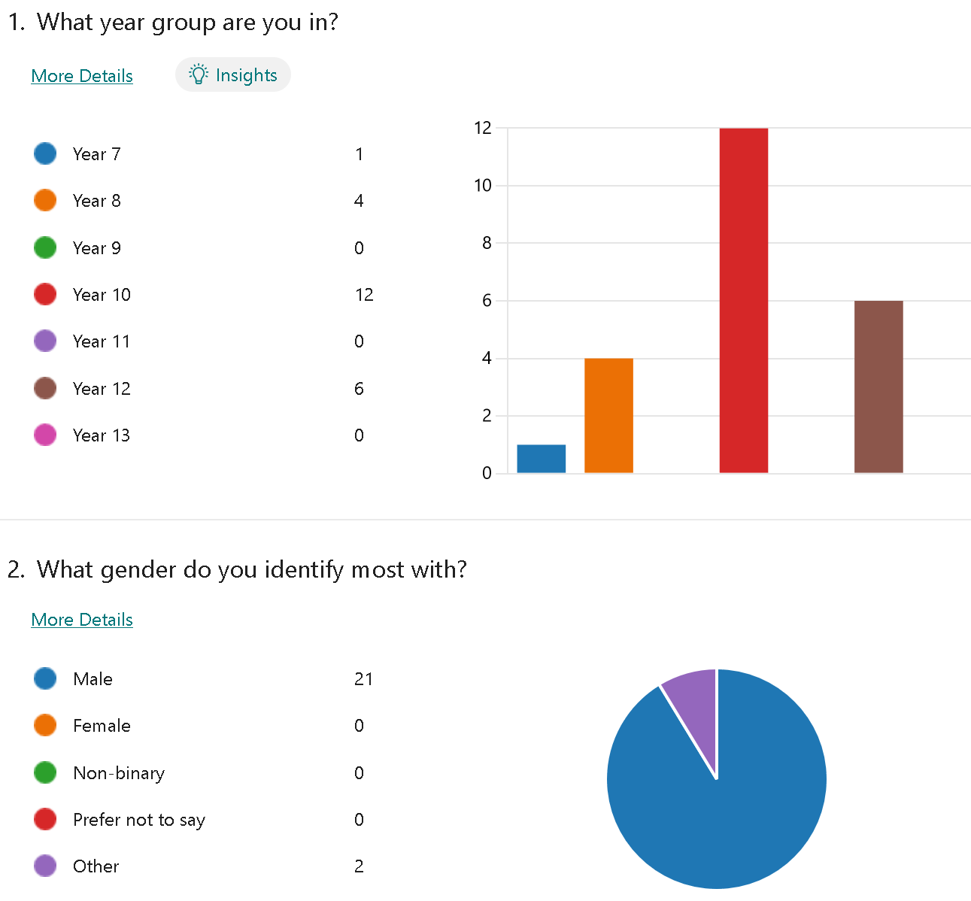

These two graphs display the main target audience well, 14–15-year-old males.

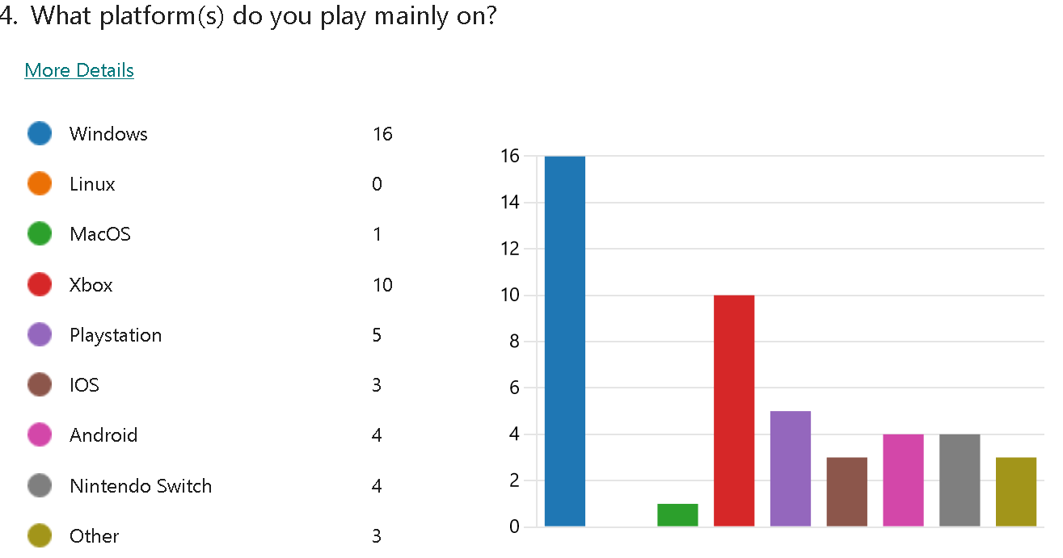

This graph shows that PC players are the primary group. As such, the development will focus first on a PC release. Attempting to develop for multiple platforms in this project would be difficult due to the time cost. Therefore, PC will be the priority and the others catered to, should time permit.

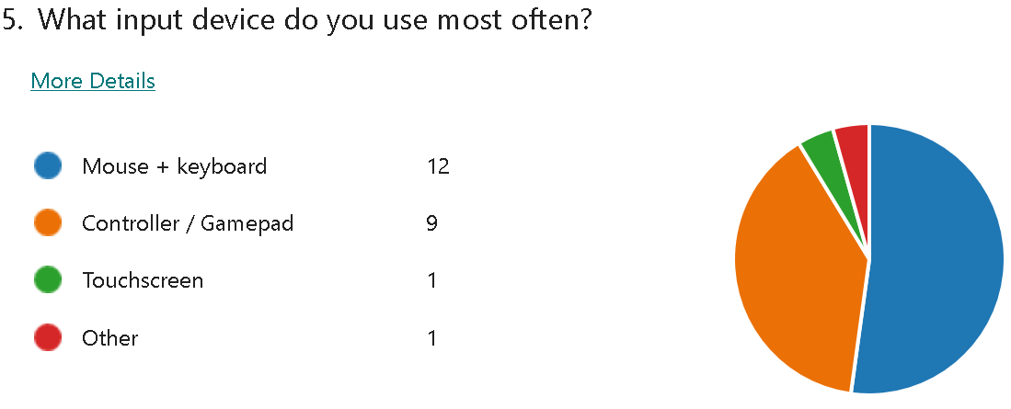

A factor I did not consider is support for gamepad input. This most likely stems from the support of a console release, but gamepad support should be considered. It has been shown that rebindable controls are a major desire of players with other indie games in the past.

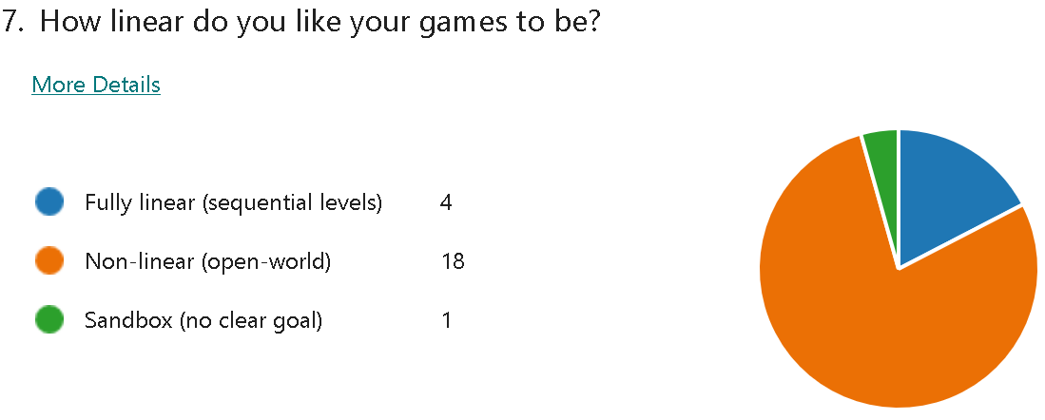

An open-world game is clearly the best choice here as it was a landslide victory. The game was originally planned to be this as well.

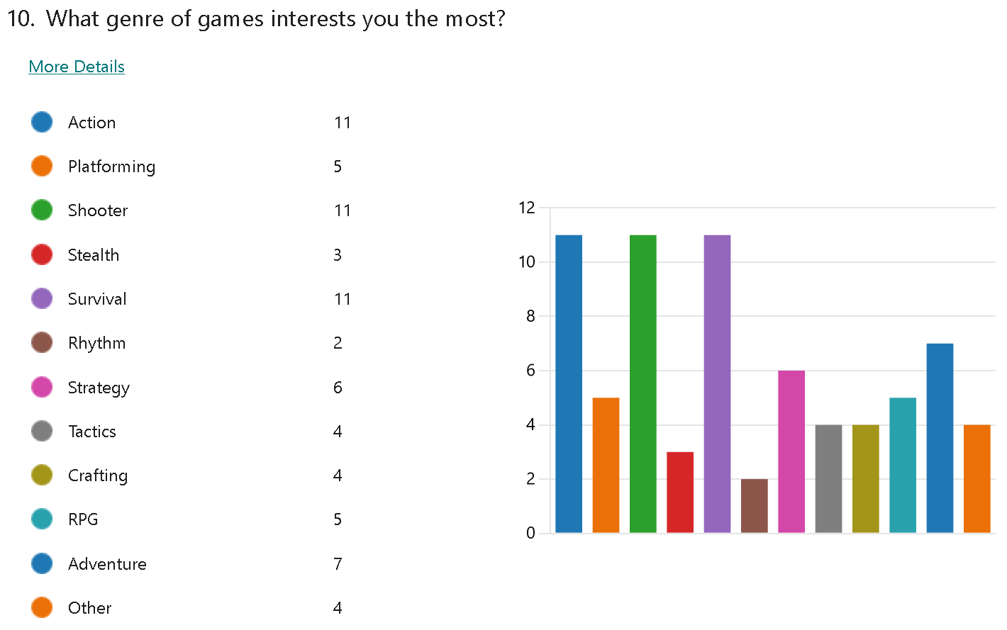

A few conclusions can be drawn from this graph.

The first is that an action/shooter are two of the three most popular tied choices despite this, the project will remain an RPG at its core. This allows me to cater to the third category that received 11 votes, survival. By having my project be an RPG with adventure and survival elements (survival partially encompasses crafting in addition), I can reach a larger audience.

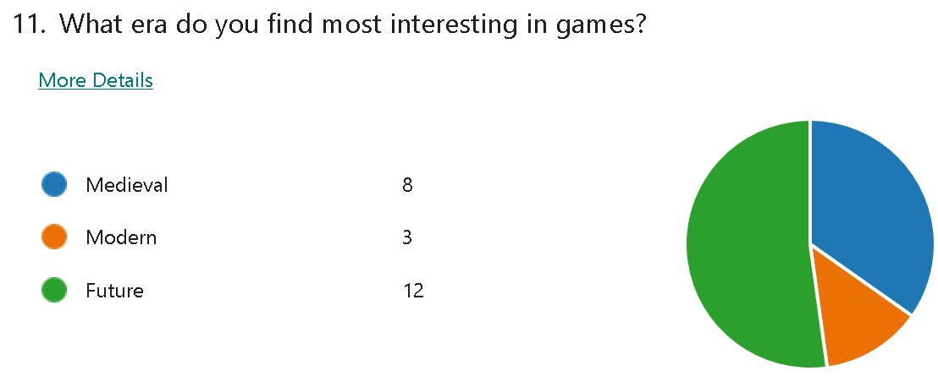

Future is the main demographic here, though ignoring the 35% who voted medieval would be bad. As such moving forward, a mix of the two should be incorporated into this project.

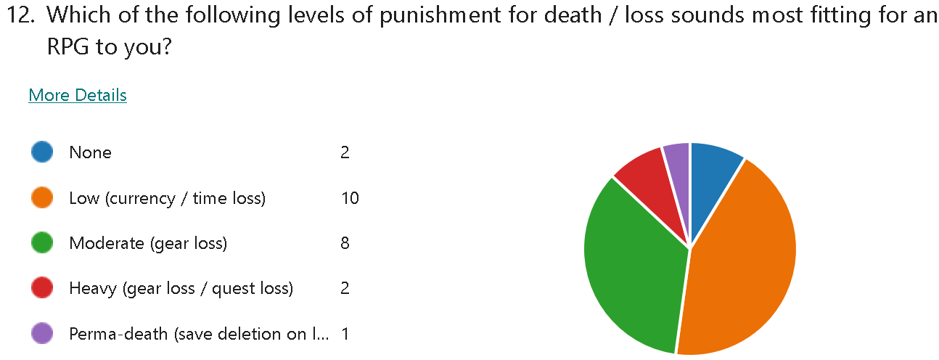

The same is true for this question, except the margin is slimmer. I believe that all of these should be offered as a choice at the start of the game, as it would not be all that hard to implement and would ensure that all players are happy. “Low” or “Moderate” would most likely be recommended, while the others are for the extremes of the player base.

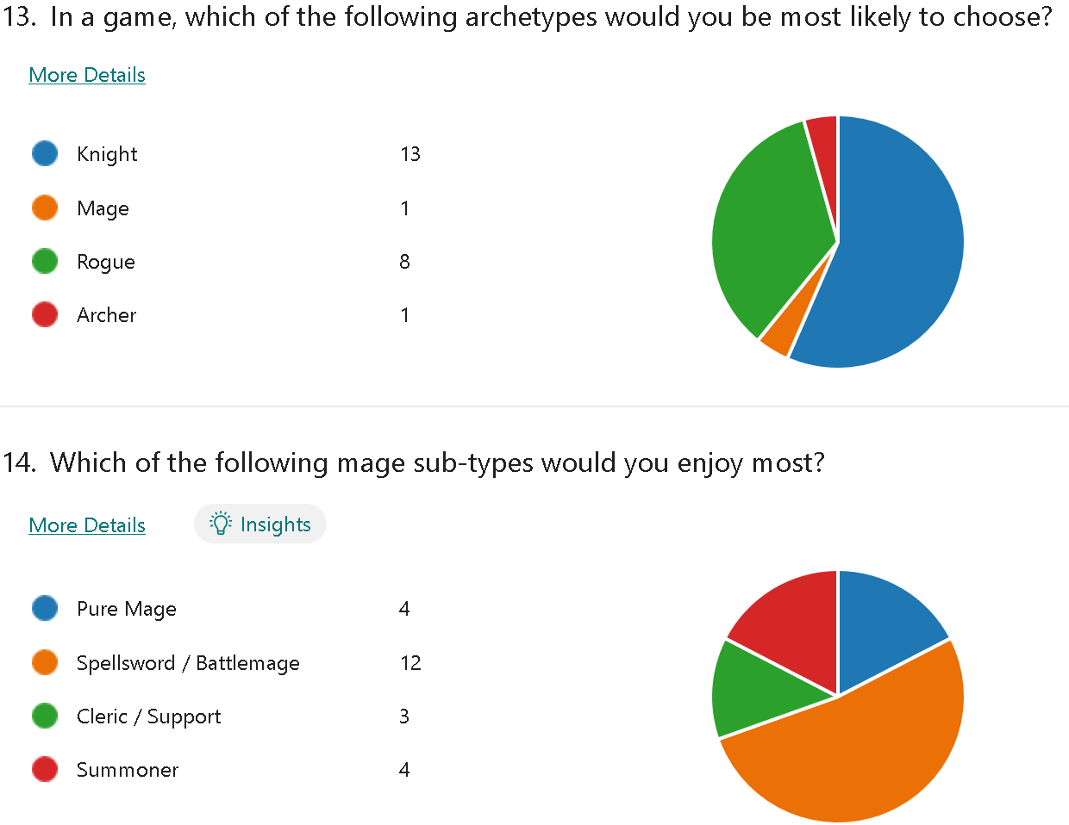

The data here shows that there is a desire for a mix of playstyles, the game originally planned to focus almost entirely on magic, yet the data here shows that physical attacks are in fact, more popular.

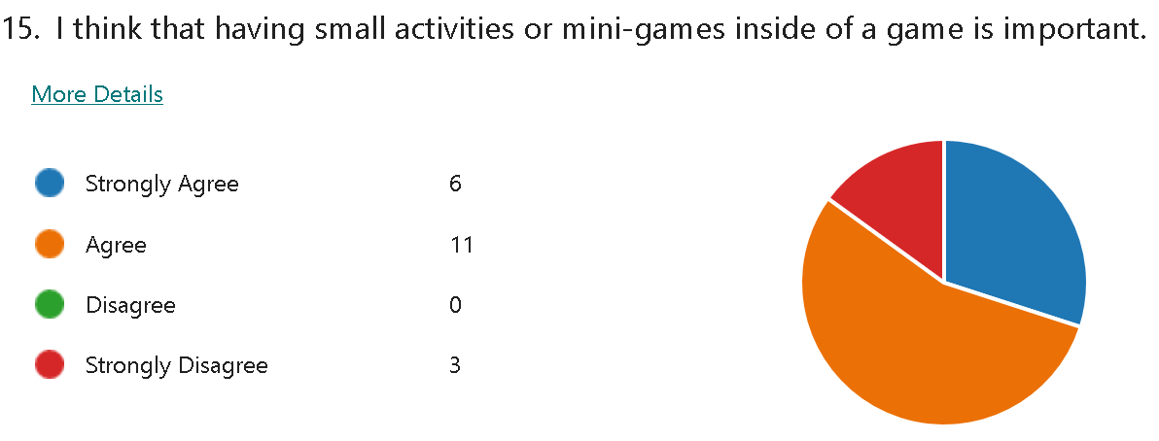

This data clearly shows that a portion of dev time should be dedicated to side activities as 85% of the respondents showed a desire for them.

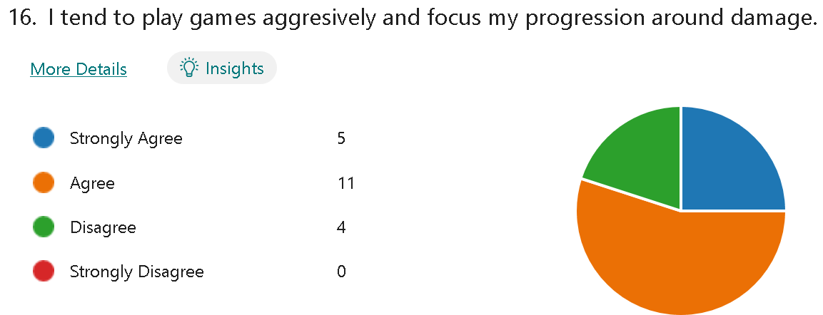

This data shows that 80% of respondents play aggressively. This means that the game should certainly allow this playstyle and perhaps reward it.

An adrenaline or rage system similar to that of the Calamity mod from Terraria could be implemented and will be discussed within the research section.

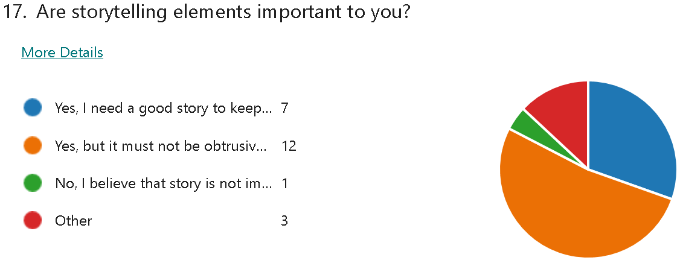

Note: The 3 other respondents gave weak positive responses (“Yes but gameplay is more important”) prior to an edit of the question.

This data shows that a story is important to the respondents. For the scope of this project, story elements will be minimal. However, If I had more time story elements would be a priority after gameplay.

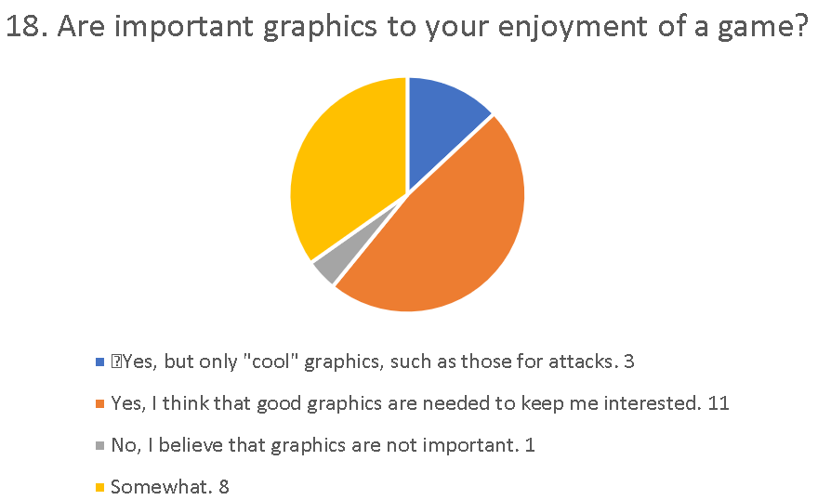

Note: The slightly different appearance of this graph is due to an edit causing all previous data to come under “other” despite the choices only being reworded.

This data shows that graphics are quite important to the respondents. The time limitations of this project mean that graphical elements are likely to be placeholder or lower quality than the respondents would like.

This is alright, as this project is likely to deliver a game demo, rather than a full experience.

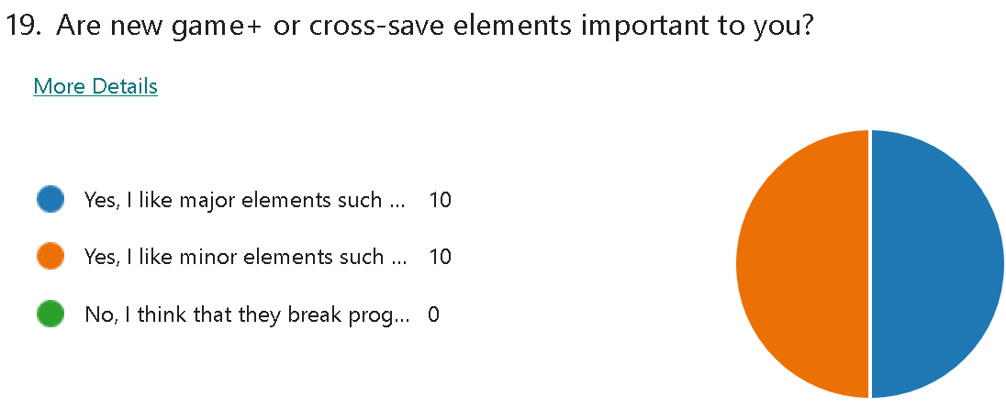

100% of respondents had a positive opinion on cross-save elements. Evidently, it is worth implementing these. An option could be added to disable them If a player desires, however, the polled demographic clearly would support cross-save elements. Outward has a new game+ system that I believe works well and will be discussed in the research section.

Note: Questions 20-21 have received 0 responses at this time due to being new additions, as such they are omitted.

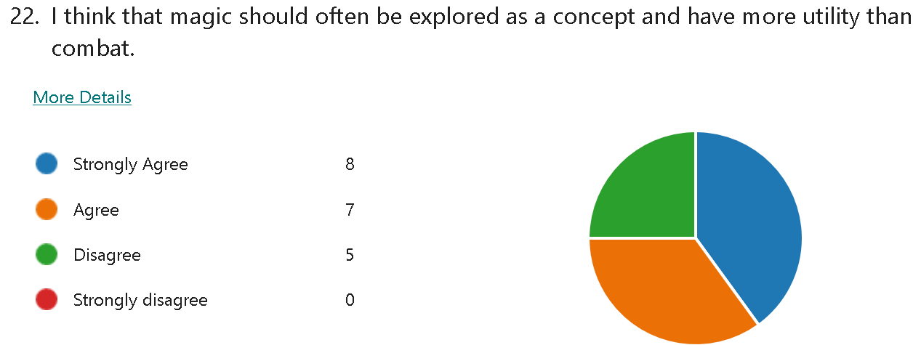

A majority agreed that magic should be explored outside of combat. This could be both for skills but also the plot. This result reinforces the idea of a mixed setting as the future element could come from magic technology.

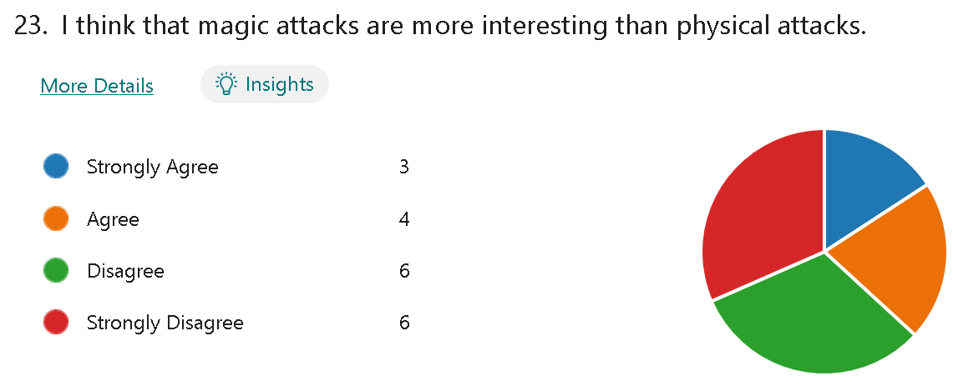

This data shows that physical attacks are of high importance to the correspondents.

This presents 2 differing ideas, either focus on physical attacks more or present a newer, fresh view of magic within games. Not separating the two entirely or giving both utility with each other would allow me to keep the original idea of this project while satisfying the respondents.

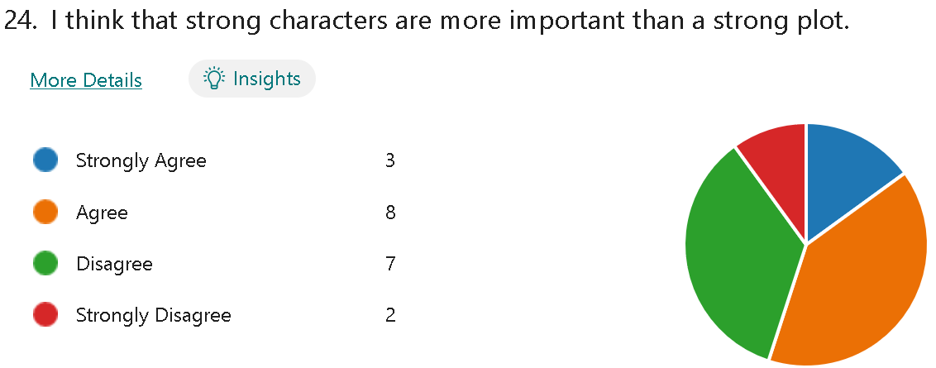

This data shows a minor preference for characters over plot.

As mentioned in the analysis of the data from question 17, story elements will be minimal in this version.

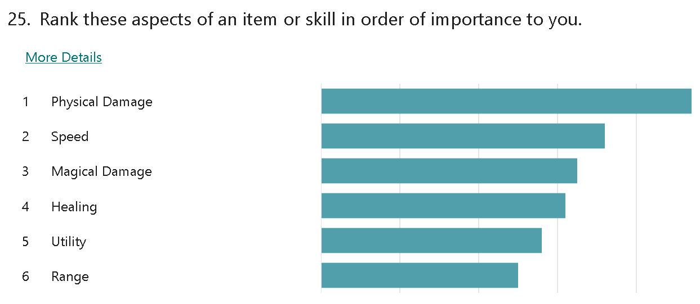The data here should influence the design of items and skills in the game.

Clearly, damage is the most crucial factor to the respondents. This aligns with the previous data saying that respondents preferred aggressive playstyles (range being last supports this too).

Skills and items seemingly should reward a player for being aggressive.

To avoid alienating some playstyles, there could be a class/archetype system that gives a “bonus” bar that rewards playing like that archetype.

In the case of a battlemage, it could reward being close to the enemy and dealing damage, while a summoner could be minion damage and count and a pure mage lack of damage taken and mana spent.

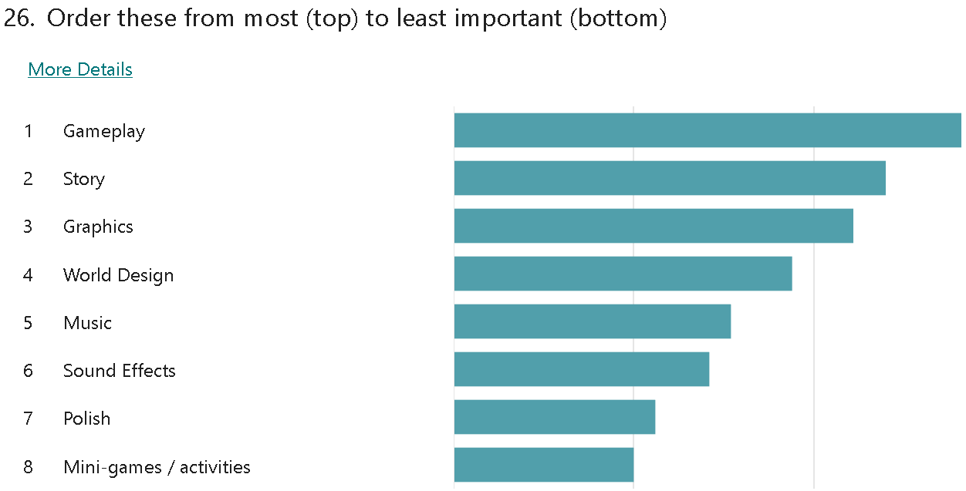

This data shows that gameplay comes more than anything else for the respondents.

This means that most of the development time should be spent refining and improving this aspect.

The story, graphics, sound effects and music are of mixed importance to the respondents, and due to artistry not soliciting credit within this project, would only be focussed on once all other aspects are to a high standard.

World Design somewhat intertwines with gameplay, as a poorly designed world indicates gameplay flaws.

Polish will be applied in the final stages of the project. This is because the time and effort invested into polish may go to waste if the feature is changed or even scrapped.

Mini-games rank last, despite their previous positive reception. As such they will be included at a low priority.

**Research:**

Terraria (Calamity):

Within calamity, there is a system that I would like to take inspiration from. This system is the Adrenaline and Rage system.

Firstly, rage builds when you are close to an enemy. Once the bar is full, you can spend the bar to gain 35% more damage for a limited period.

Rage is lost once you are too far, or do not deal damage to any enemy for longer than 10 seconds.

Adrenaline is similar but different, the buff is +200%, though it is far shorter, and builds constantly during a boss fight. It is lost upon taking damage.

I would like to use elements from this as it aligns with how most respondents play (according to my survey), however, the adrenaline provides an option for a more defensive or evasive playstyle.

Outward:

I would like to mirror the progression of Outward in some ways. Upon learning any new skill or obtaining equipment there is a noticeable increase in the power of the player.

I would like to somewhat take inspiration from the pace of combat in Outward but with more focus on being aggressive.

Something that I do not want to take from outward is the trade-off of health for mana, as I would like to facilitate an adaptable playstyle. Another aspect I will not be taking is the heavy reliance on synergies, as it would take a lot of time to design and I also believe that it would not fit with the promoted aggressive style, synergies are important to prevent the player from spamming a single spell, but in outward, magic is useless without synergies.

**Fictorum:**

I plan to take some inspiration from Fictorum’s magic editing system.

I would like to ensure that each spell the player receives are all impactful and have clear use but may also be adapted somewhat to increase variety.

To explain this, I will run through the magic system in Fictorum first.

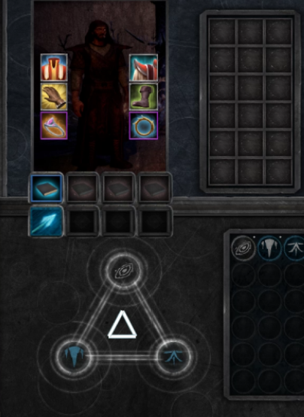Pictured here (behind the rune) is the inventory for Fictorum, including equipped items, spells, and active runes.

Almost all spells can equip 3 runes. These runes allow you to modify a spell when shaping it. Runes can alter the origin (casting location), the projectile (what is cast), the impact (behaviour on collision) and the general stats (damage, speed etc).

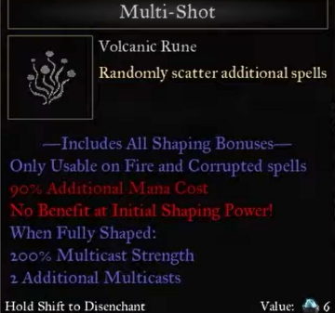Also pictured here is a rune with all its effects in front of the inventory. It does not modify the origin or impact but adds 1 additional projectile alongside several stat effects. These effects are only applied when the spell is fully shaped as specified.

Shaping a spell costs additional mana and takes longer but will apply the full effect of its runes.

In Fictorum, runes are somewhat random. In my implementation, I would like to make these uniquely so that I can tailor them more as that is more fitting with a longer-form RPG, such as this project, compared to a rogue-lite.

I could also make them craftable to increase the number of things that can be crafted.

**Skyrim**

I would like to take limited inspiration from Skyrim’s magic system. I would like to have a similar system of splitting magic into schools and having skills developed within them. However, I would like to have each of my spells be individually more impactful than the ones in Skyrim, as you tend to depend on a single spell for a long time and have many that make each other obsolete.

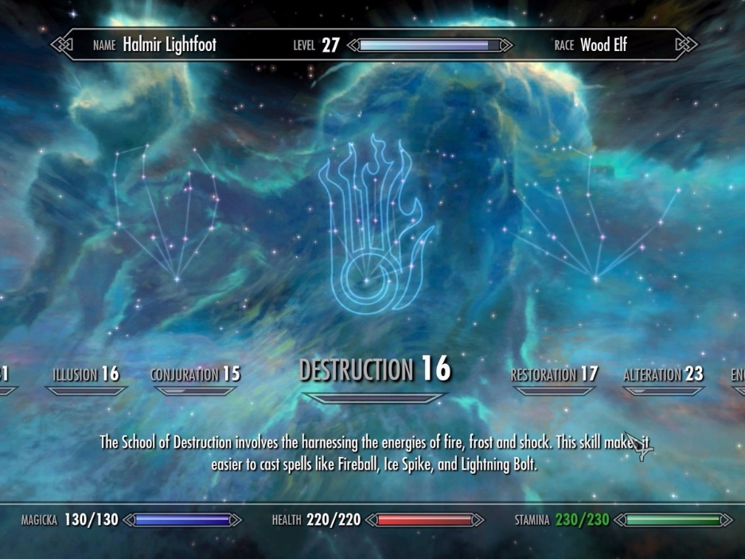

Photo of the skill tree screen showing the schools of magic, along with player levels in each.

**Essential Features:**

My essential features are as follows:

1st person camera System:

Obviously, a camera system must exist for this project. I believe that a 1st person camera system would be the best fit for this project, this is because it is more immersive than a 3rd person or top-down camera and allows for the application of effects to the camera to facilitate immersion.

Another reason for a 1st person camera is it will save on dev time due to not having to model or animate a player.

Player Statistic Tracking:

I will need to track several key statistics on the player for distinct reasons. Health will need to be tracked to facilitate a loss condition, stamina to have a limit on physical skills and sprint time and mana to have a limit on magic usage.

Going beyond those basic 3, I will need to track the player's defence to ensure that damage reduction is applied.

WASD Movement System:

Also obviously, the game will require the ability to move. I believe that keeping the controls very similar to most others will be useful as it means that anyone with even limited experience with gaming can jump right into mine. I can implement more unique movement as well, but by keeping the basics basic, I can leverage the familiarity that the player will have.

Inventory and Equipment System:

Almost every RPG has an equipment system. This one will be no different, equipment is an effective way to facilitate progression.

I will have to keep track of what the player has equipped, is carrying and also store the data for this, along with every item in the game somewhere.

Along with just keeping track of what the player has equipped, I will need to apply its effects

Magic System:

As a magic-centric RPG, a magic system is obviously an essential feature. I will have a list of spells that each have clear and differing purposes. Mana must be tracked as mentioned above.

I will have to store data relating to each spell and its behaviour in different states.

Physical Weapon System:

As found in the stakeholder research, physical weapons are a desired feature. As such, I will have to also have physical skills similar to the magical ones. These could be affected by a strength stat, rather than an intelligence stat to allow more builds.

Procedural Terrain:

I would like to implement procedural terrain between Points of Interest to add some replayability.

AI:

As an RPG, AI to battle with and against are necessary to fill out the world.

Rage / Adrenaline:

As discussed in the research, this system will incentivise being aggressive.

**Computational Methods:**

Abstraction:

Many details of reality can be abstracted out of this game due to it not being realistic, for example, temperature and hunger. This game is not marketed as a survival RPG and therefore these details are not needed.

Many statistics can be abstracted before being shown to the player, for example, defence can be an integer rather than a percentage.

Decomposition:

I can break down my project into modules to allow reuse and to make this problem easier to tackle.

The problems to tackle when broken down are:

Player Stat / Skill Tracking

Physical Weapon Handling

Magic Attack Handling

Player Movement

Player Inventory

Global Item Database

Skill Tree

AI movement

AI attack handling

Rage / Adrenaline

These do not represent the modules that would be created, only the problems to tackle.

Divide and conquer:

These smaller problems are still challenging but solvable. By solving these problems individually and then combining them into a modular program will make the grand issue easier to solve and make use of the divide-and-conquer method of problem-solving.

**Limitations:**

Time is a major limiting factor in this project, game development projects can take many people years to reach a final product.

Due to this, this project aims to deliver more of a demo/slice of an entire game. All aspects that would be present in the final product will be in the demo, however, the depth of the implementation will be less.

Another limiting factor is my lack of previous experience in completing a full project.

My previous experience is both in another language (python) and smaller scope projects.

**Solution Requirements:**

**Hardware:**

A dual-core processor will most likely be fast enough to run my project as it will not be intensive.

4GB of memory will also likely be sufficient.

A keyboard or controller to input commands.

**Software:**

Windows 7 or later will likely be sufficient to maintain compatibility.

**Success Criteria:**

A survey would be sent to stakeholders to gather opinions and feedback on each aspect of the game and success would be determined on that.

This checklist would be used both before and post-survey to aid in the judgement:

Enjoyable gameplay for replayability.

1st person camera System.

Player statistic tracking.

Intuitive movement System.

Easy to use inventory and equipment system.

Deep and interesting magic System.

Physical weapon system.

Friendly and enemy AI.

Useful and intuitive UI to convey key information.

Unique skills and weapons.

# B. Design

## DECOMPOSITION

## Systems diagram

# C. Developing the coded solution (“The development story”)

<See H446-03 Project Advice Booklet for help and guidance on what must go here.>

# D. Evaluation

<See H446-03 Project Advice Booklet for help and guidance on what must go here.>

# Project Appendixes

Insert as many project appendixes as you need for your project.

These might include, but are not limited to:

* Complete Code Listing (ESSENTIAL)
* Interview Transcripts
* Meeting notes
* Observation notes or questionnaires

TODO:

Format the research so that it’s less horrifying.

More photos in research.

Better researched requirements.

Expand on abstraction.

Test requirements to be more accurate when the project is more complete.

Fill in decomposition with more info and be more specific. amog

Expand success criteria.

Cost : Resource ratio added to skill question.

Add personal details before submission.

General formatting.

